Supplementary data A:
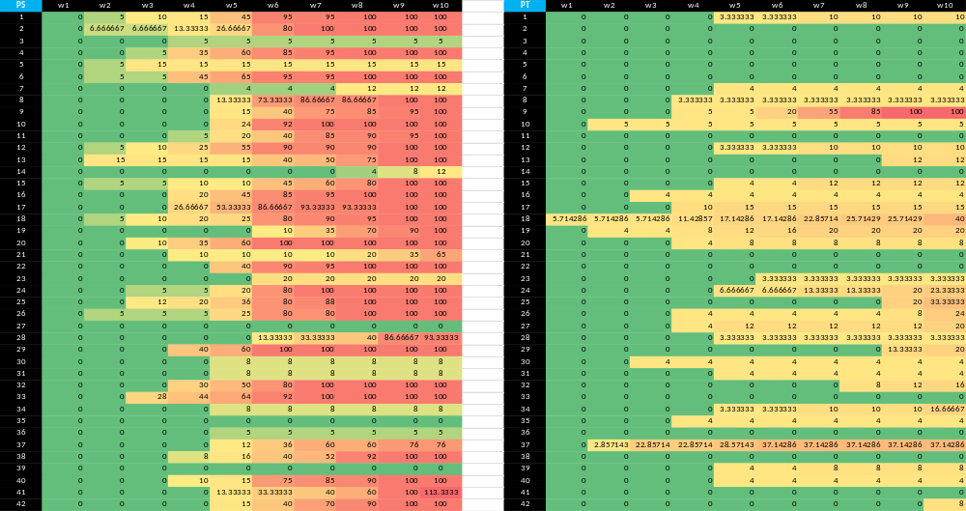
Representative disease severity index (DSI) scores of selected oil palm clonal varieties from Week 1 to Week 10 following infection.
Figure S1: PT refers to potential tolerant, while PS refers to potential susceptible. The colour gradient represents the Disease Severity Index (DSI), ranging from 0% (healthy; green) to 100% (severely infected; red). Intermediate colours indicate increasing disease severity, with green representing healthy plants, yellow/orange representing increasing levels of infection, and red representing severe infection.
The DSI was calculated using this formula (Ab Wahab et al. 2026):
DSI (%) = $\left(\frac{Ʃab}{N.K}\right)$ × 100
Where,
$Ʃab$ = sum of the symptomatic leaves with their corresponding score
N = total leaves
K = highest score scale
Table SX. Disease Severity Index (DSI) scoring scale used to evaluate disease symptoms in oil palm leaves.
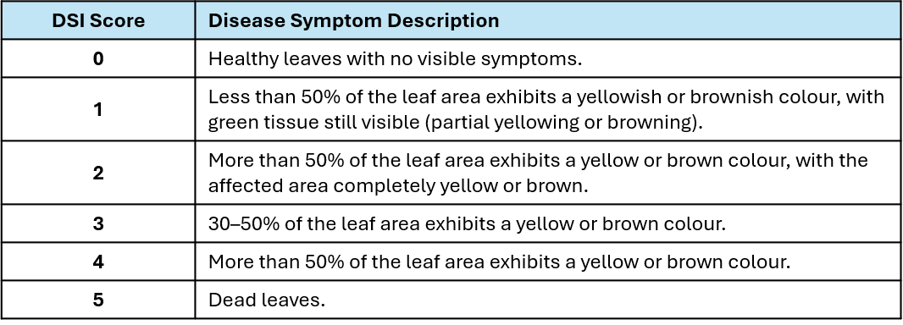
Supplementary data B
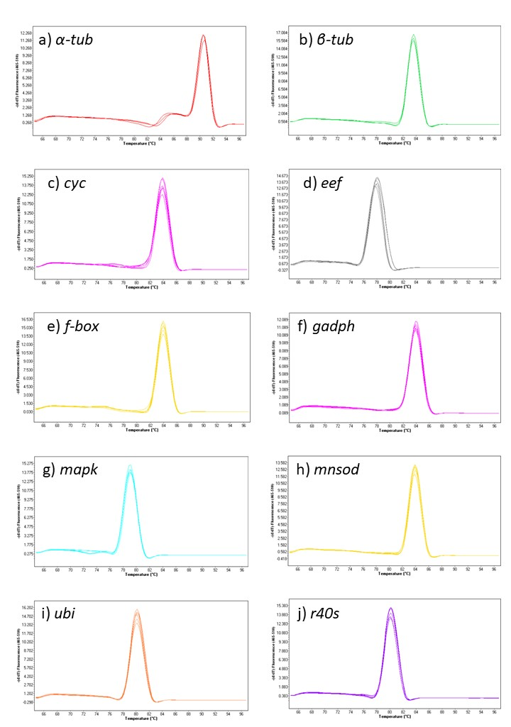
Supp data B. Melt curve analysis of the RGs on oil palm root (a) α-tubulin, α-tub (b) β-tubulin, β-tub (c) cyclophilin, cyc (d) Elongation factor, eef (e) F-box, f-box (f) glyceraldehyde-3-phosphate dehydrogenase, gapdh (g) mitogen-activated protein kinase, mapk (h) manganese superoxide dismutase, mnsod (i) ubiquitin-conjugating enzyme, ubi (j) 40S ribosomal protein, r40s
Supplementary data C

Supp data C. The ΔΔCq values of the ten reference gene (RG) candidates across G. boninense infection time points. Each panel represents one RG candidate and displays the corresponding ΔΔCq values across the different G. boninense infection time points (1–8 wpi). Different coloured data points represent the respective infection time points.
